## /sud

### Step 1: Ensure/Double Check Permissions on Sensitive Files

1. Permissions on `/etc/shadow` should allow only `root` read and write access.

- Command to inspect permissions:



- Command to set permissions (if needed):



2. Permissions on `/etc/gshadow` should allow only `root` read and write access.

- Command to inspect permissions:



- Command to set permissions (if needed):



3. Permissions on `/etc/group` should allow `root` read and write access, and allow everyone else read access only.

- Command to inspect permissions:



- Command to set permissions (if needed):



*Is the command saying, “permission denied” because the permission is correct? ***Using Sam as an example.***

4. Permissions on `/etc/passwd` should allow `root` read and write access, and allow everyone else read access only.

- Command to inspect permissions:



- Command to set permissions (if needed):



### Step 2: Create User Accounts

1. Add user accounts for `sam`, `joe`, `amy`, `sara`, and `admin`.

- Command to add each user account (include all five users):









2. Ensure that only the `admin` has general sudo access.

- Command to add `admin` to the `sudo` group:



### Step 3: Create User Group and Collaborative Folder

1. Add an `engineers` group to the system.

- Command to add group:



2. Add users `sam`, `joe`, `amy`, and `sara` to the managed group.

- Command to add users to `engineers` group (include all four users):

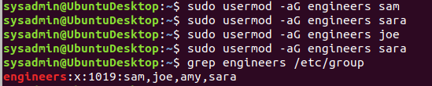

3. Create a shared folder for this group at `/home/engineers`.

- Command to create the shared folder:



4. Change ownership on the new engineers' shared folder to the `engineers` group.

- Command to change ownership of engineer's shared folder to engineer group:

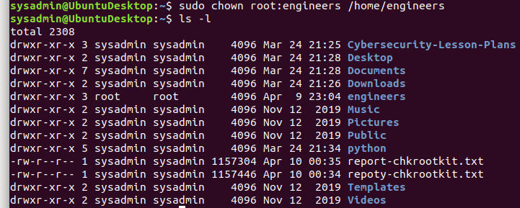

### Step 4: Lynis Auditing

1. Command to install Lynis:

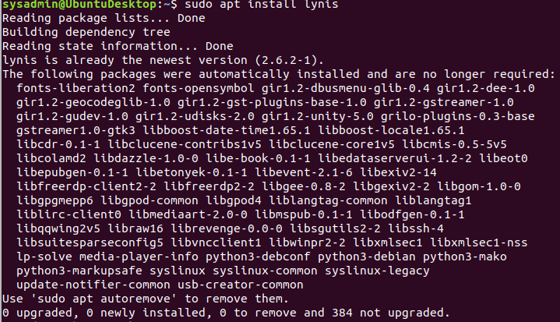

1. Command to see documentation and instructions:



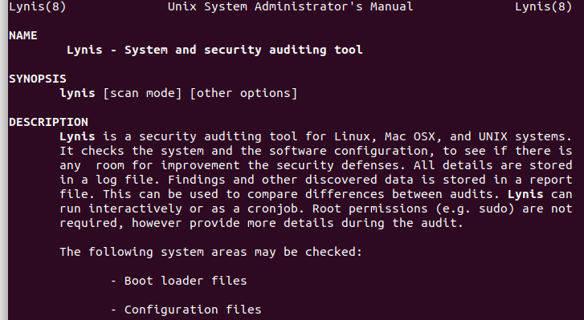

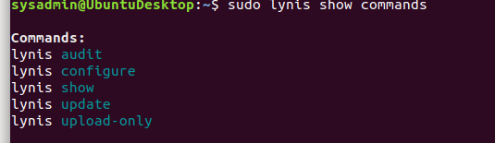

1. Command to run an audit:



1. Provide a report from the Lynis output on what can be done to harden the system.

**\*There are 57 ways in the report to harden the system. Report is uploaded to the homework file.**

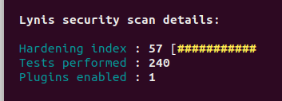

- Screenshot of report output:

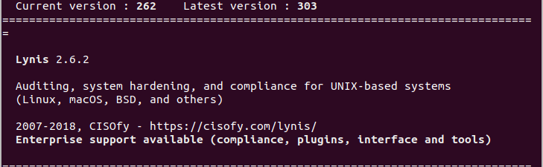

### Bonus

1. Command to install chkrootkit:

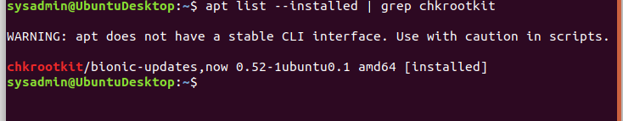

1. Command to see documentation and instructions

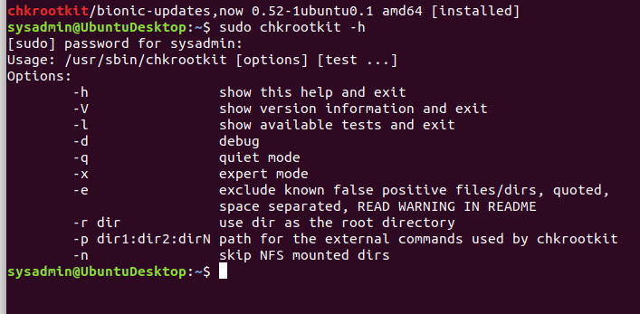

3. Command to run expert mode:



4. Provide a report from the chrootkit output on what can be done to harden the system.

- Screenshot of end of sample output:

**\*Report is uploaded to output file.**

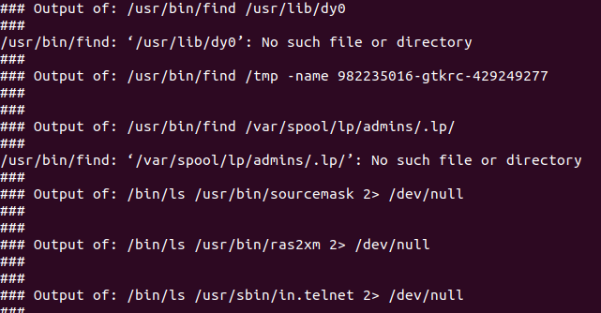

---

© 2020 Trilogy Education Services, a 2U, Inc. brand. All Rights Reserved.